GGraph
module 4
Question 1
To plot a bar chart showing the total number of upper and lower division courses in SPSS, follow these steps:
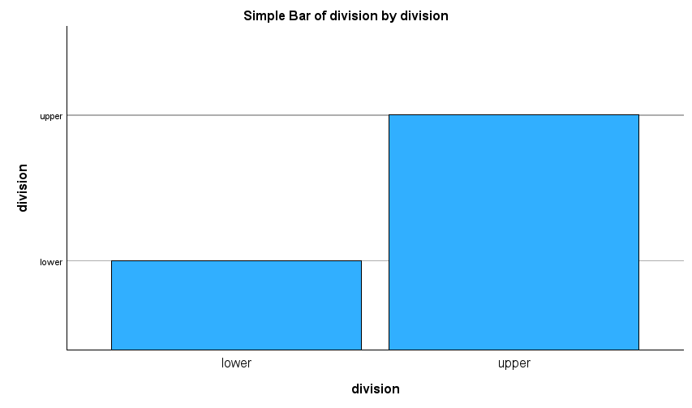

Question 2
Reproduce the chart as requested above in 1 and differentiate by credits.
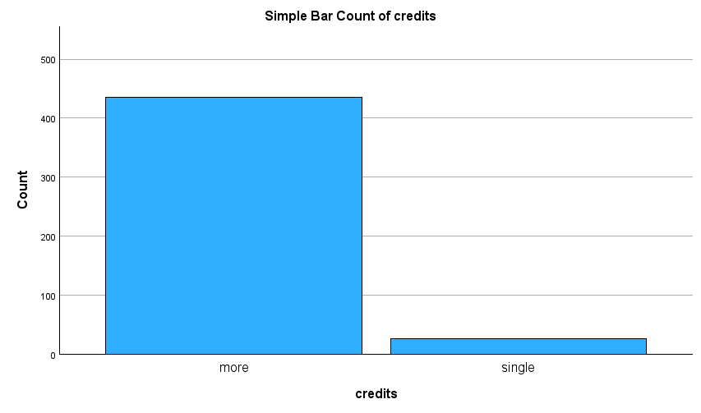
Question 3
Reproduce the chart as requested above in 1 and further differentiate by tenure.
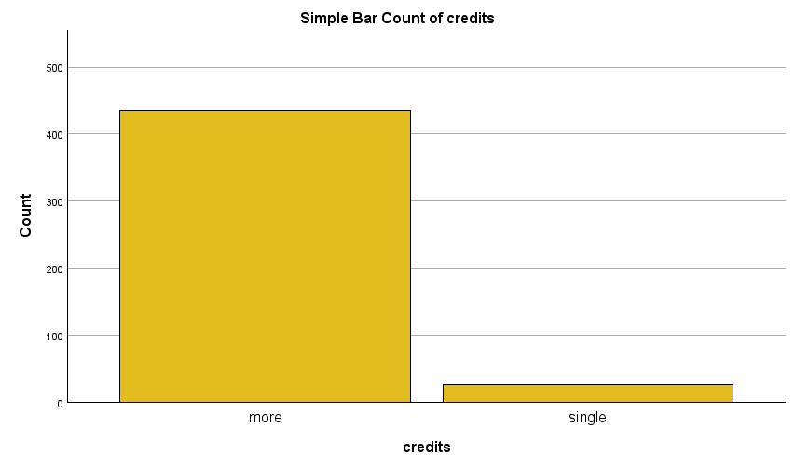

question 4

Question 5

GGraph

Question 6

GGraph

Question 7

GGraph

